**ITU NovaNexus: Unified University Management System**

**Project Information**

**Project Title:** ITU NovaNexus – Unified University Management System

**Semester:** 5 (December 2025) | **University:** Information Technology University (ITU), Lahore, Pakistan

**Supervisor:** Dr. Zunnurain Hussain | **Co-Supervisors:** Sir Umair Makhdoom

**Group Members**

|  |  |  |
| --- | --- | --- |
| Name | Registration |  |
| **Abdul Samad** | BSSE23014 |  |
| **Abdul Qadir** | BSSE23105 |  |

**Section 2.1: AWS Architecture Diagram**

**ITU NovaNexus AWS Architecture (ECS Fargate Microservices):**This diagram shows end-to-end request flow from the Internet through the Internet Gateway to a public Application Load Balancer (ALB), which routes traffic using path-based rules to three target groups (/users/*, /courses/*, /academics/*). The target groups forward requests to ECS Fargate services deployed in private subnets, where each task runs an Nginx container (port 80) proxying requests to a PHP-Apache container (port 8080), while persistence is handled by RDS MySQL and session caching by ElastiCache Redis. CI/CD is automated through GitHub Actions that builds Docker images, pushes them to ECR, and updates ECS services.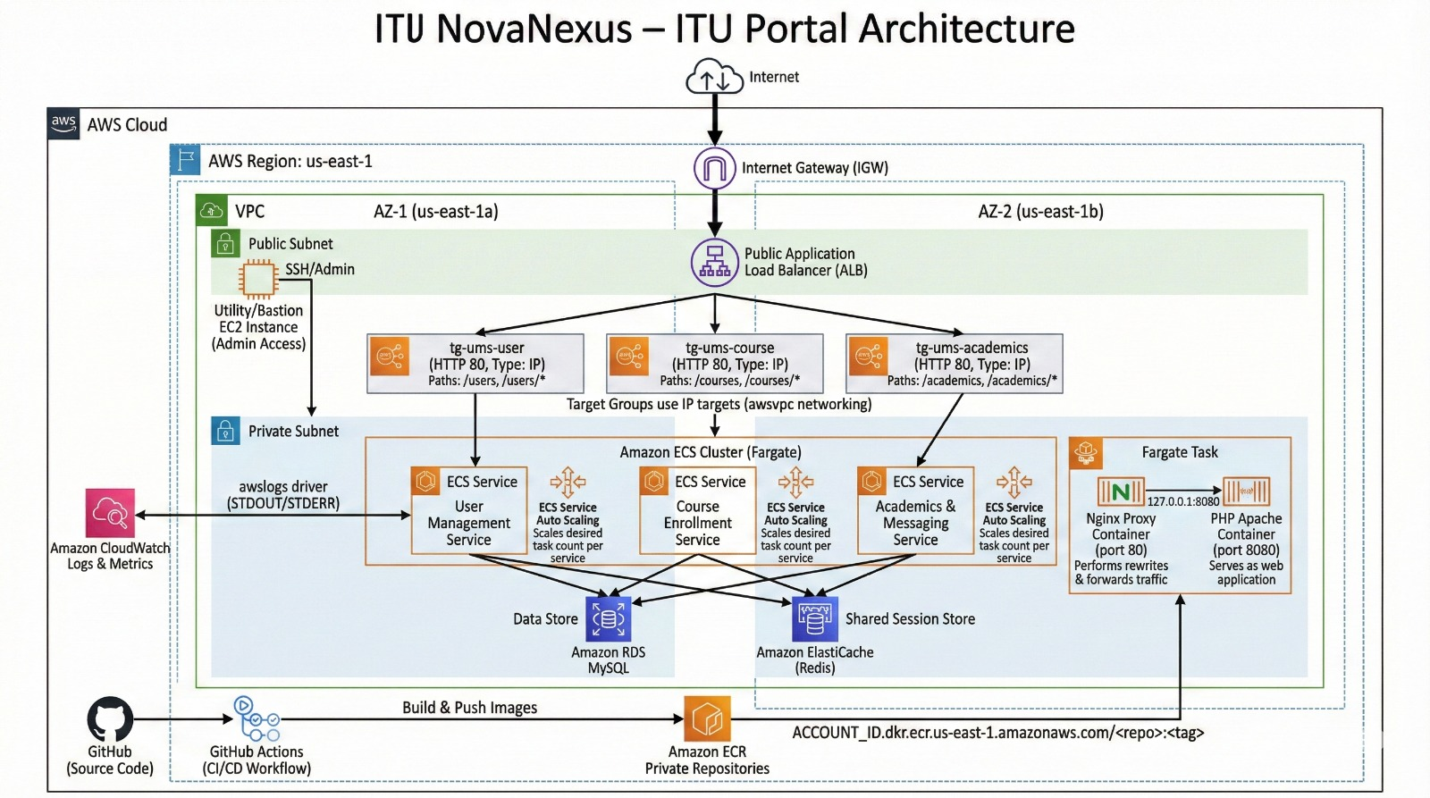

**Section 2.2: Step-by-Step Implementation (With Screenshots)**

**2.2.1 – AWS Account Setup & Environment**

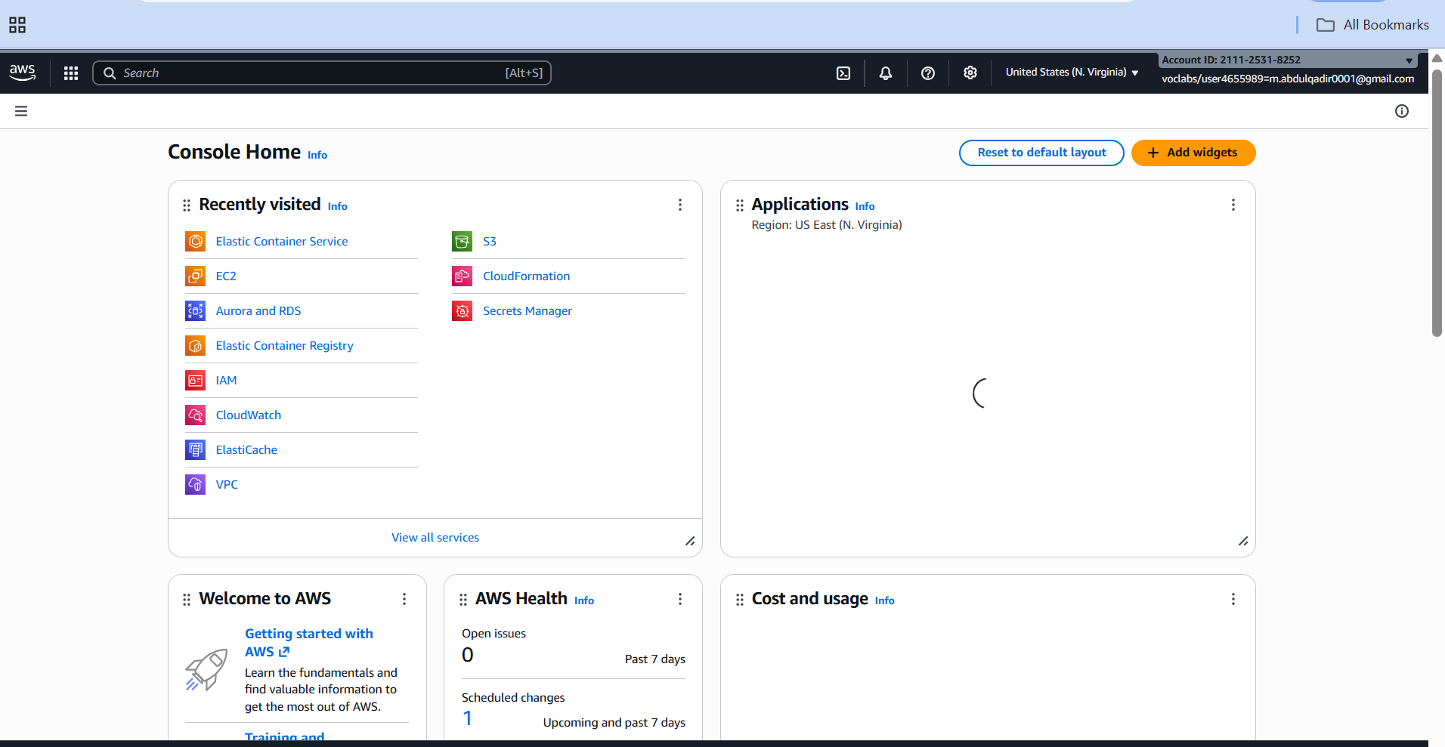

**2.2.2 – IAM Roles & Policies (Security)**

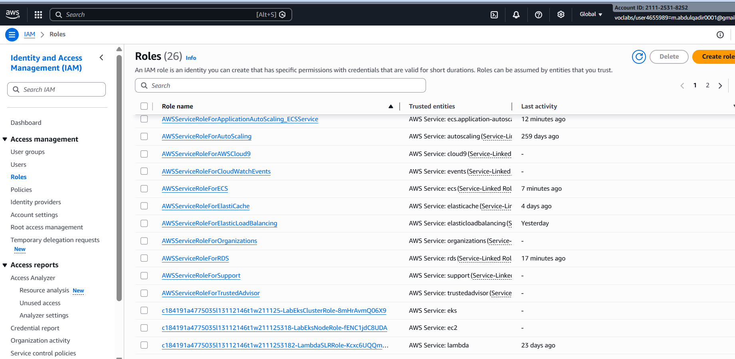

GitHub Actions OIDC/IAM role for secure deployments

* Least-privilege principle explained

**2.2.3 – VPC Architecture (Networking Foundation)**

* *VPC Setup*

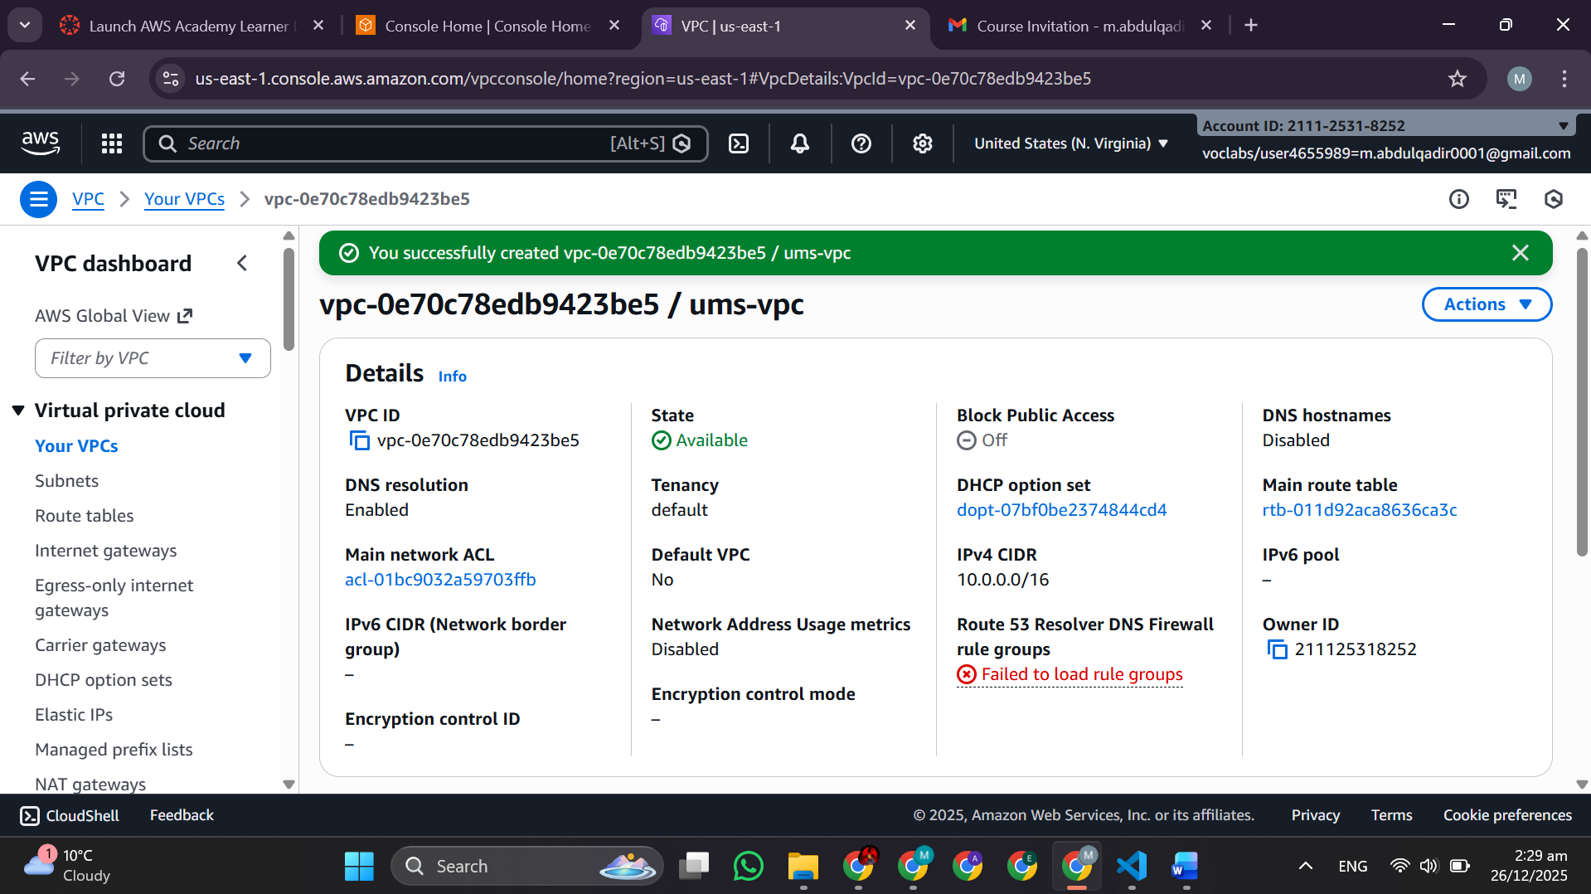

* *Subnets* (public AZ-1a, AZ-1b; private AZ-1a, AZ-1b)

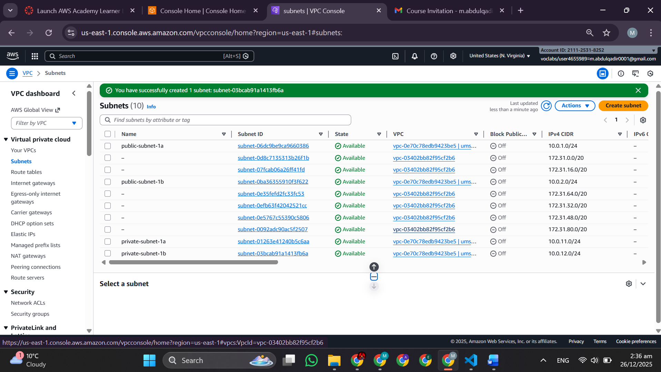

**2.2.4 – Security Groups (4 Critical Groups)**

* *ALB SG* – Inbound HTTP/HTTPS from 0.0.0.0/0

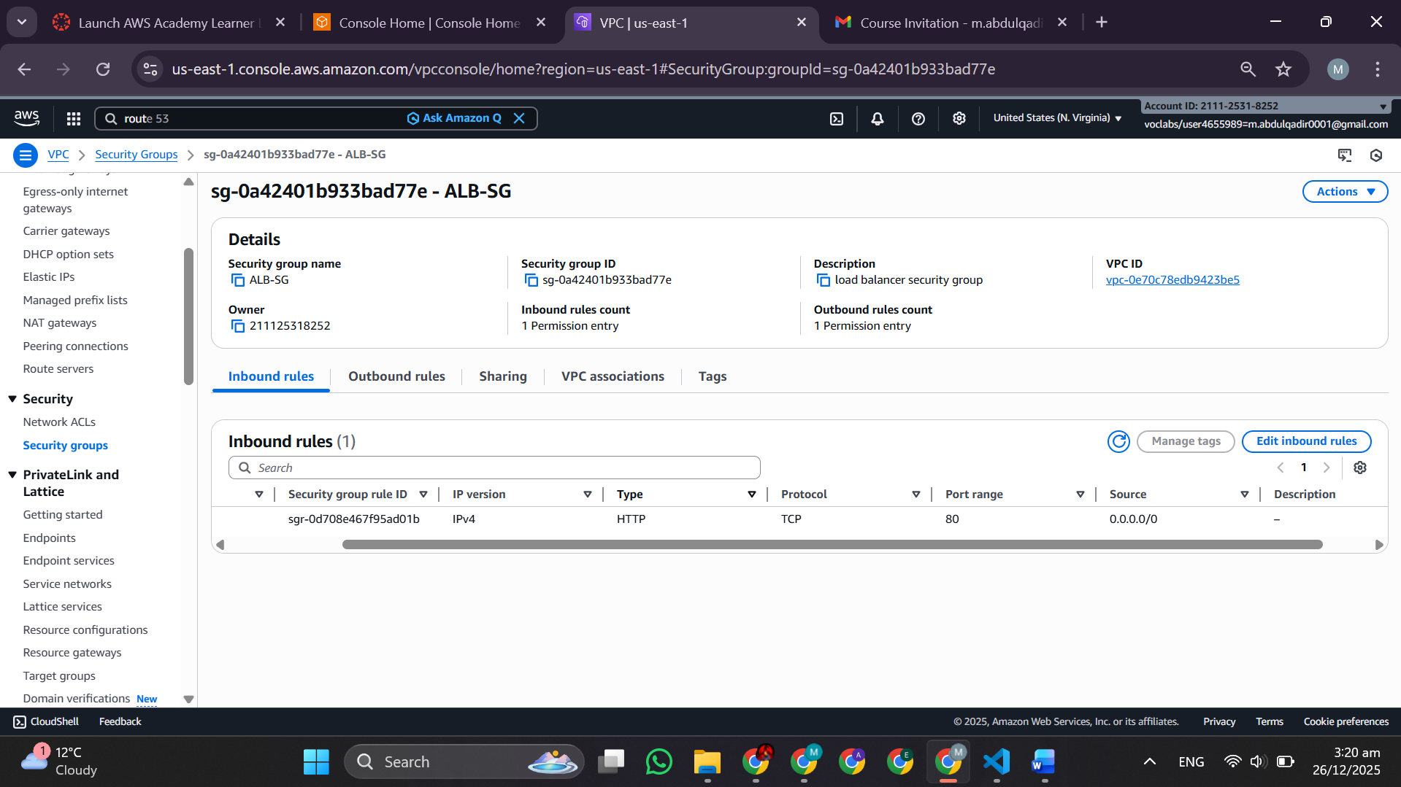

* *ECS SG* – Inbound only from ALB SG

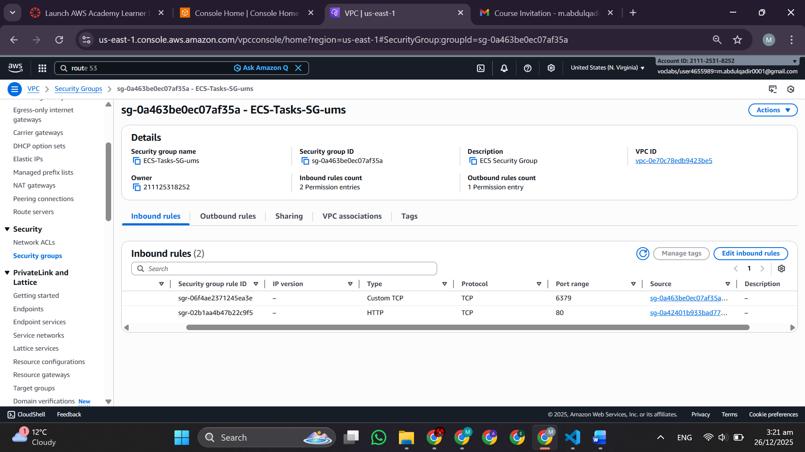

* *RDS SG* – Inbound port 3306 only from ECS SG

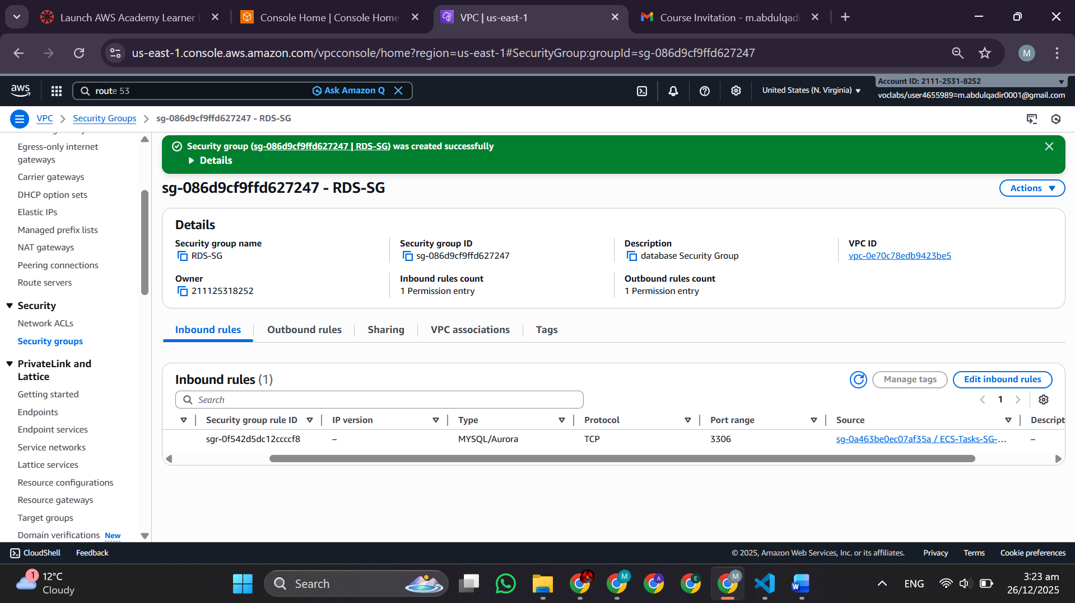

* *VPCE-SG* – Inbound HTTPS (443) from ECS SG 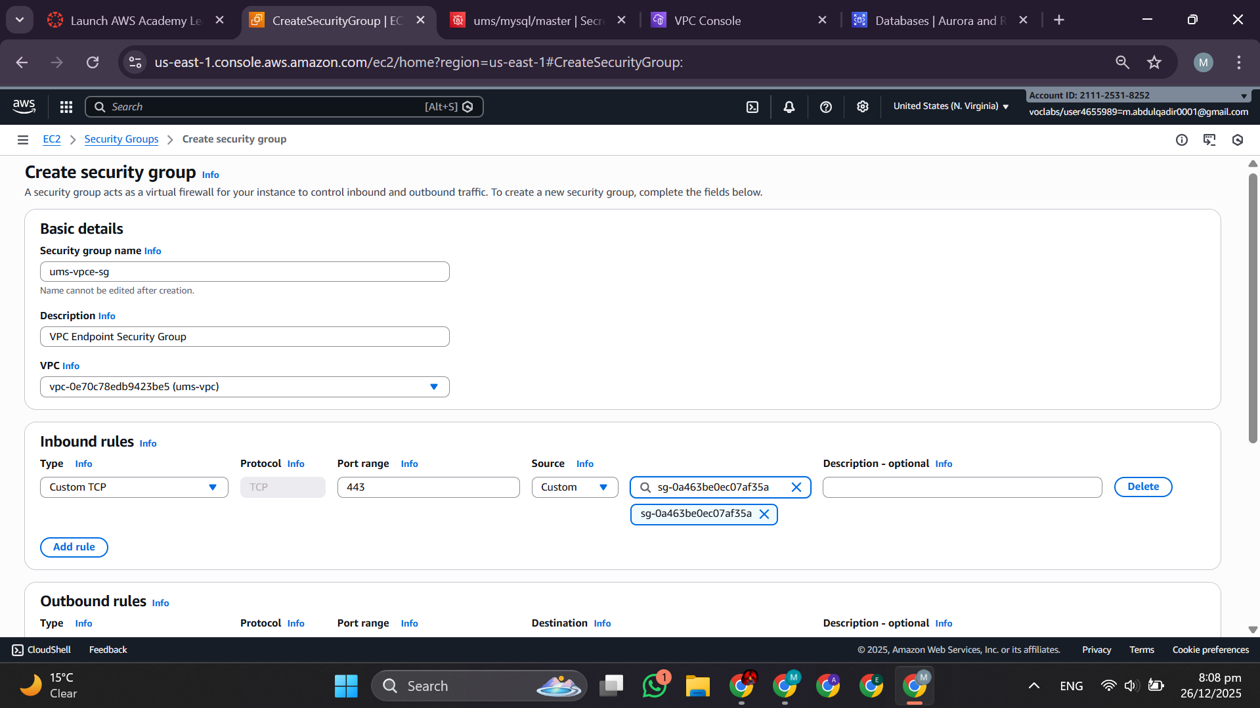

**2.2.5 – RDS MySQL Setup (Data Persistence)**

* *DB-Subnet-Group* configuration

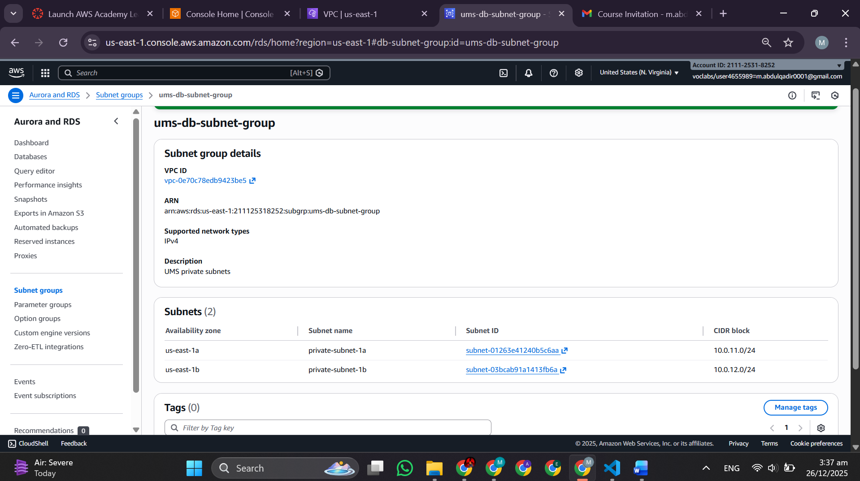

* *RDS-Creation* (Multi-AZ, t3.micro, 20GB storage)

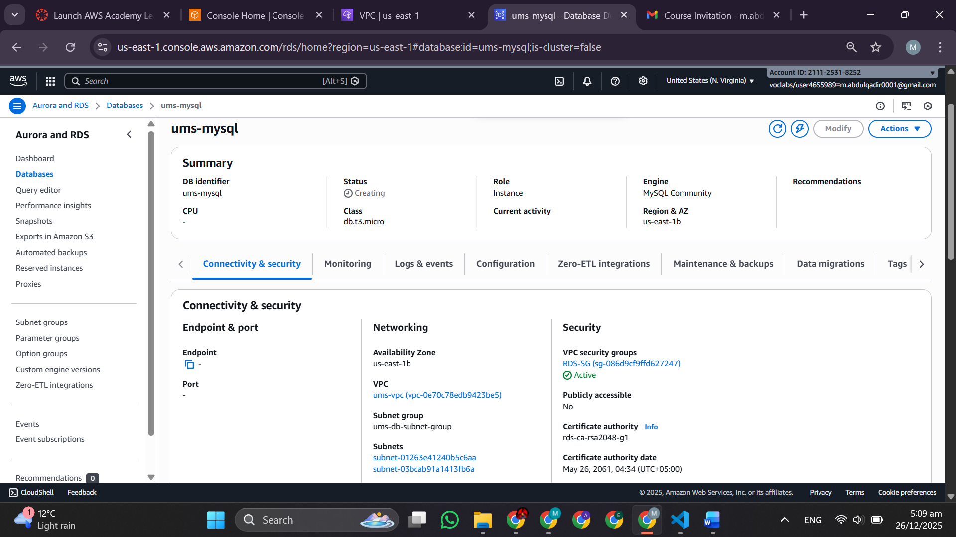

* *Secrets Manager* – Password storage (secure, not hardcoded) 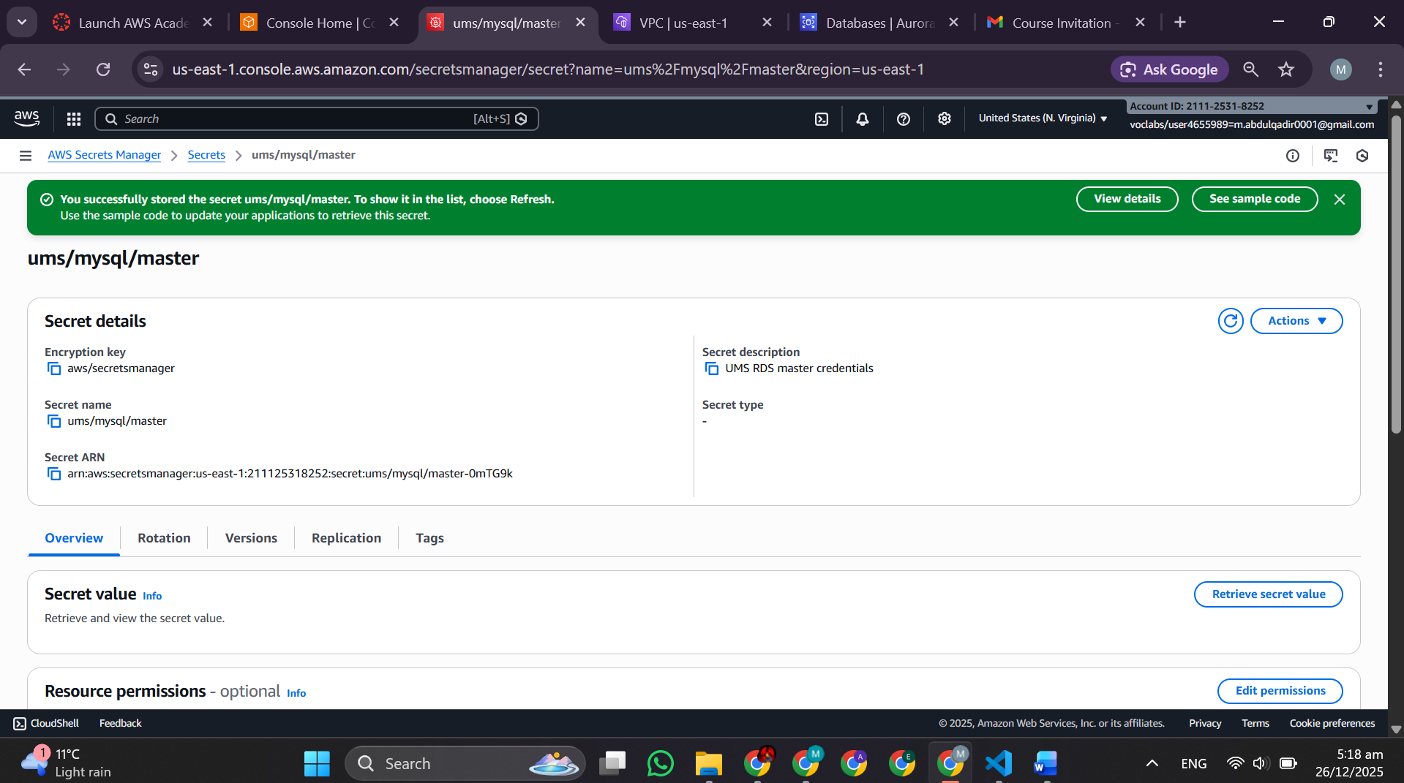
  + 1. **– VPC Endpoints (Budget Optimization)**
* *VPC Endpoints* explanation and configuration.VPC endpoints let your **private-subnet** ECS/Fargate tasks reach AWS services like ECR and CloudWatch *privately* without using a NAT gateway or sending traffic out to the public internet.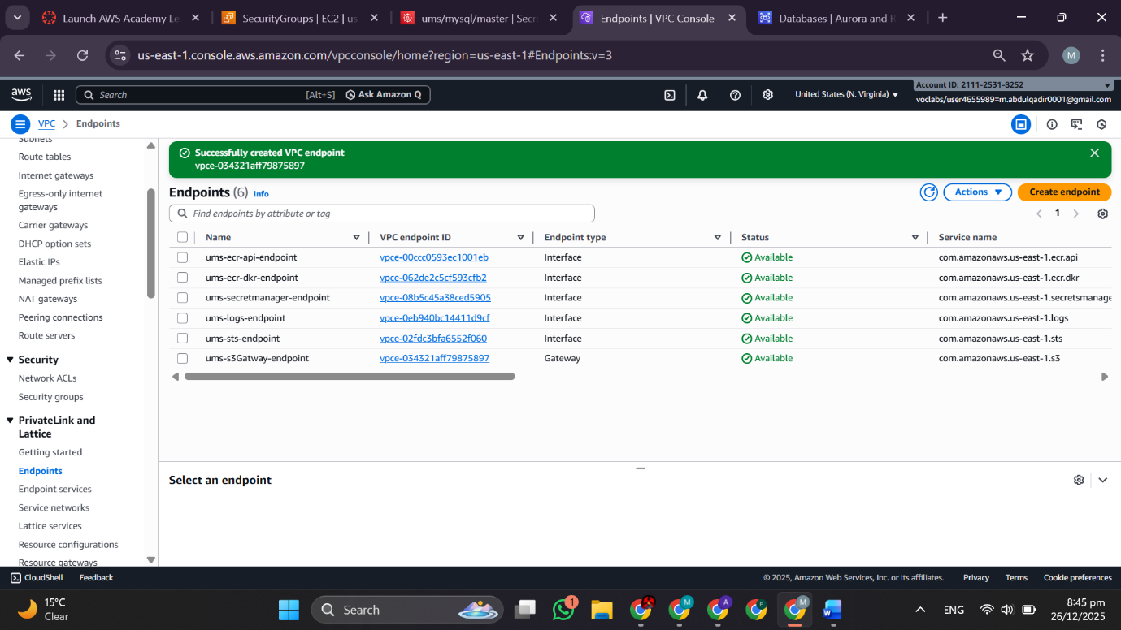Why: Eliminates NAT Gateway cost (~$45/month); allows private ECS tasks to access ECR, CloudWatch, Secrets Manager via PrivateLink

**2.2.7 – Amazon ECR Setup (Container Registry)**

* *ECR Repositories* – Three repos created:
  + itu-ums/user-management-service
  + itu-ums/course-enrollment-service
  + itu-ums/academic-messaging-service

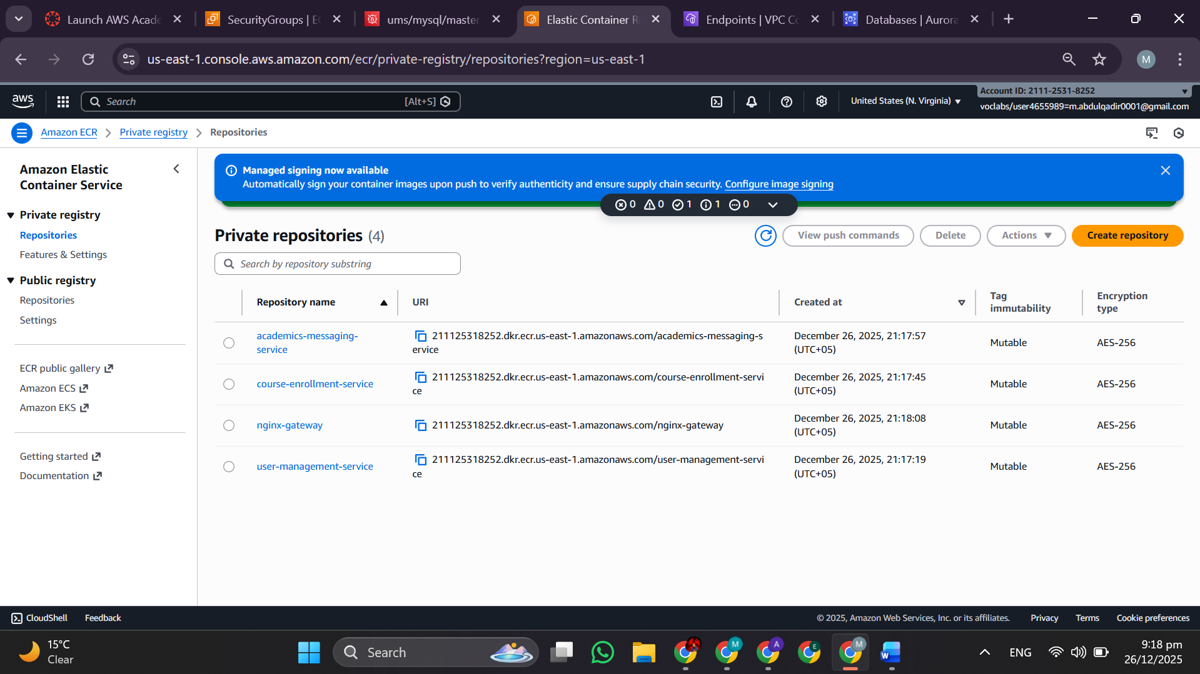

* *Build, tag, push* for each service
* Building image + tag + pushing user-management-service

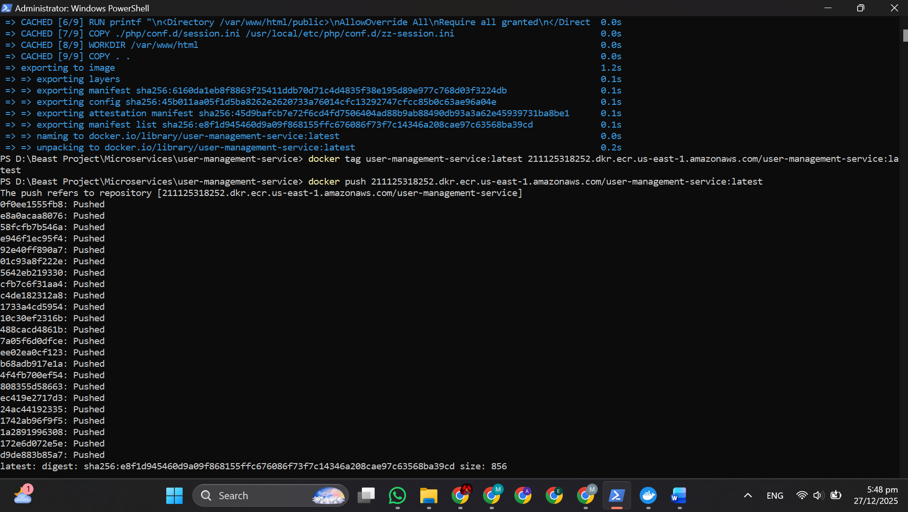

Building image + tag + pushing course-enrollment-service

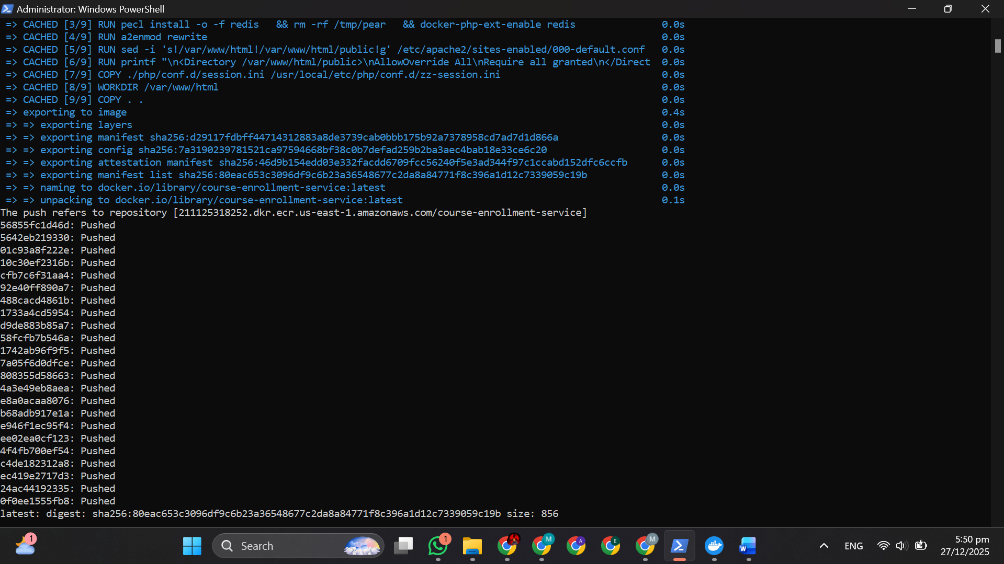

Building image + tag + pushing academic-messaging-service

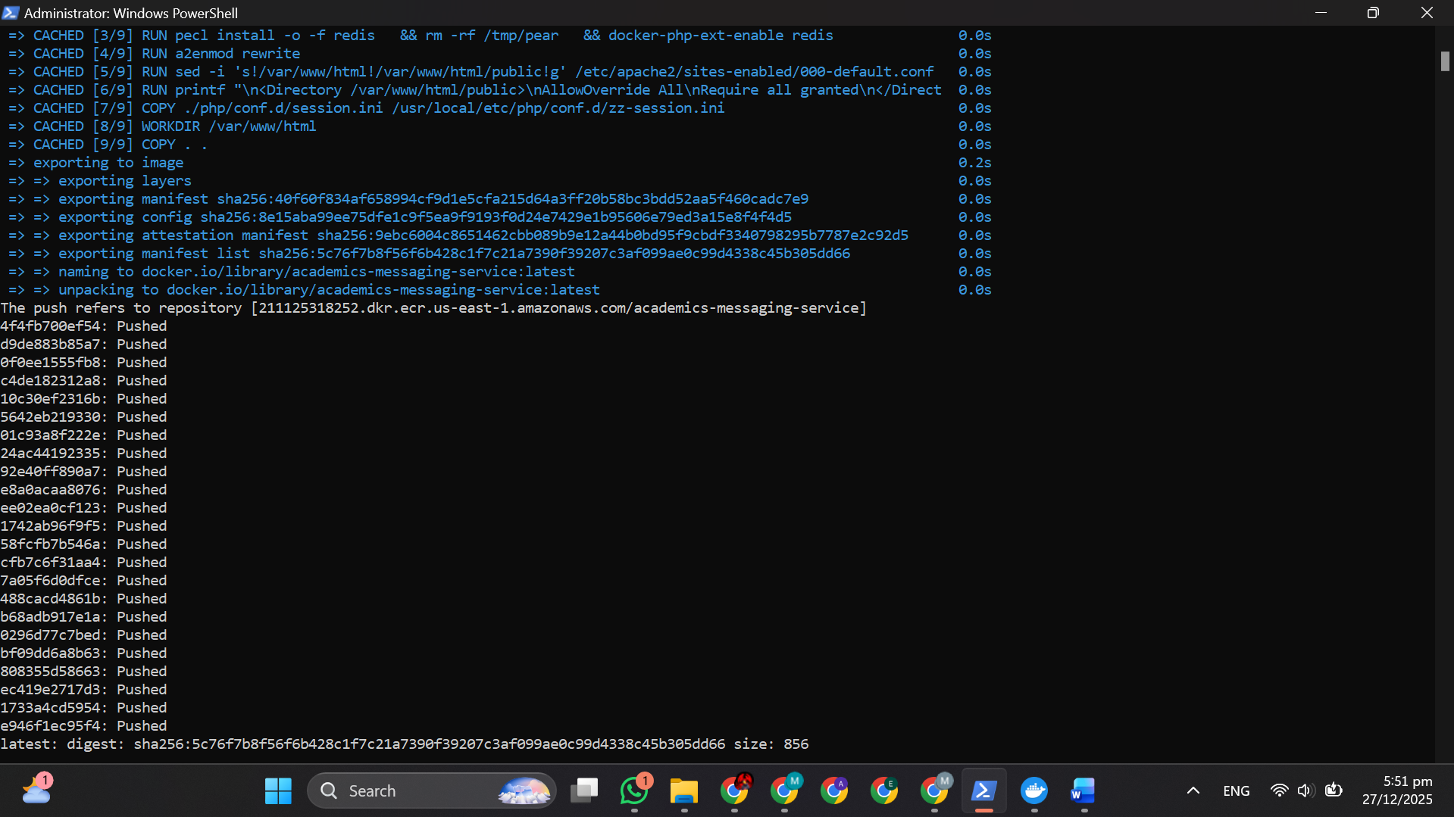

**2.2.8 – ECS Cluster & Task Definitions**

* ECS Cluster creation (Fargate launch type)

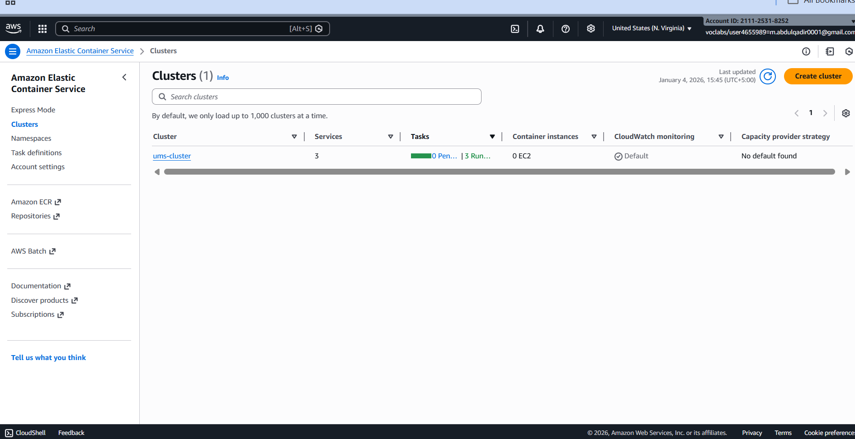

* *Task Definitions* – Memory/CPU allocation, awsvpc network mode (enables IP target groups), log driver configuration (awslogs → CloudWatch) 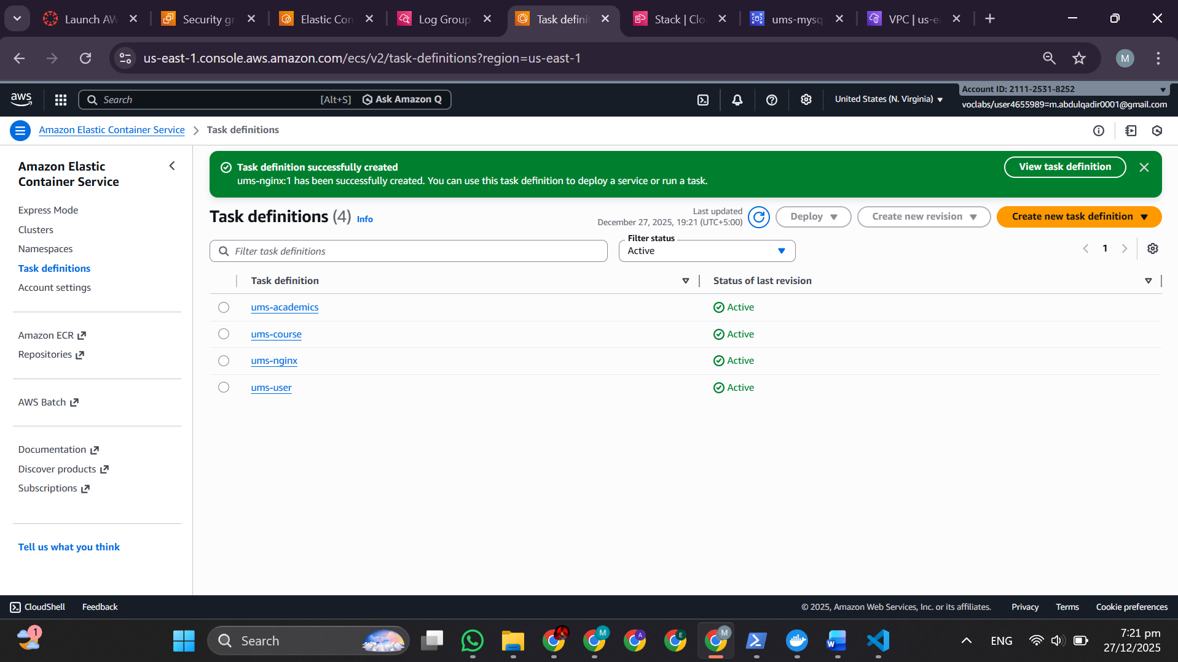

**2.2.9 – Application Load Balancer (Traffic Router)**

* *Target Groups* – IP-based, health checks (/health endpoint every 30 sec) 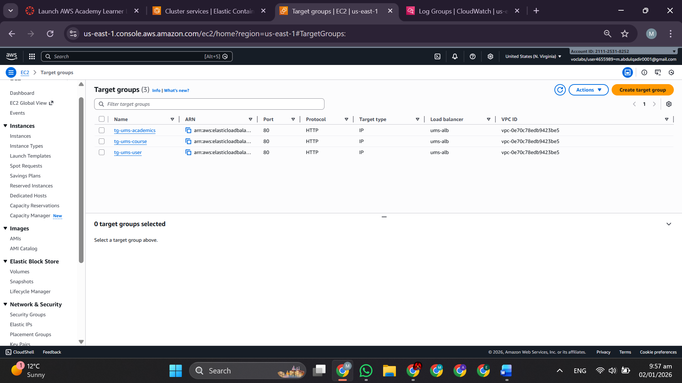
* *ALB* – Path-based listener rules:
  + /users/* → tg-ums-user
  + /courses/* → tg-ums-course
  + /academics/* → tg-ums-academic

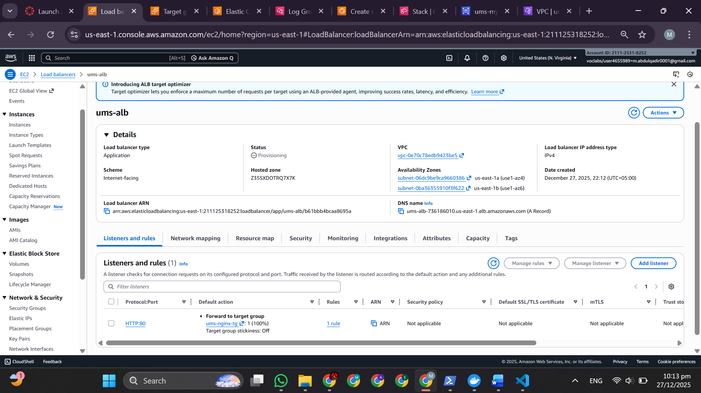

* *ALB Setup for ECS Services* – Service registration with target groups

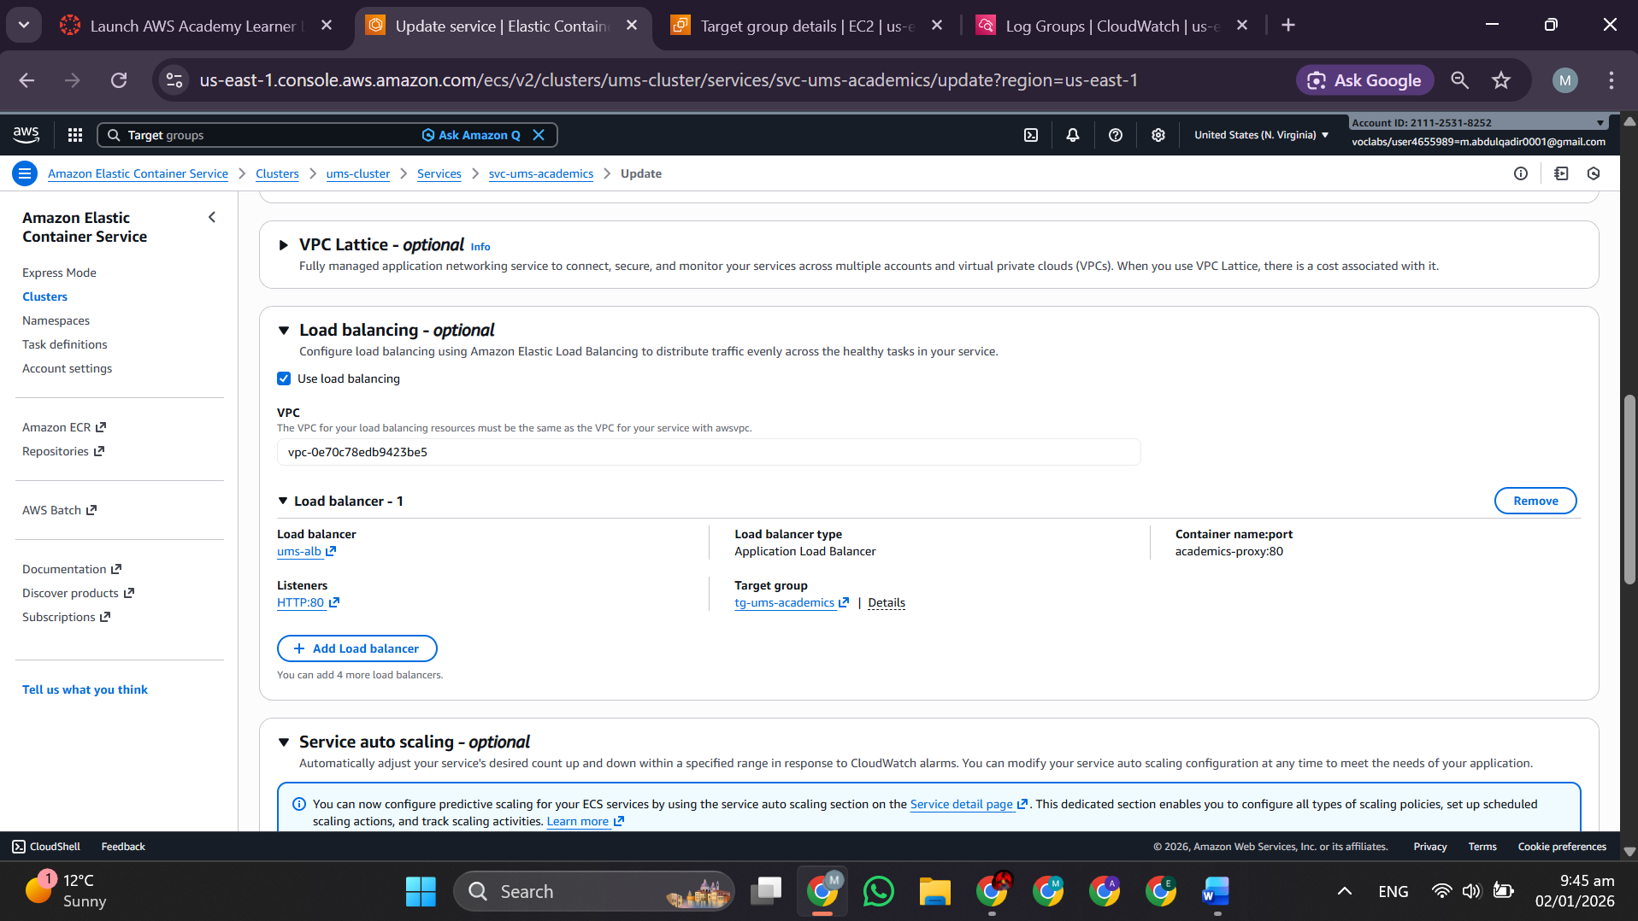

**2.2.10 – Auto Scaling Policies**

* *Auto Scaling for ECS Services*

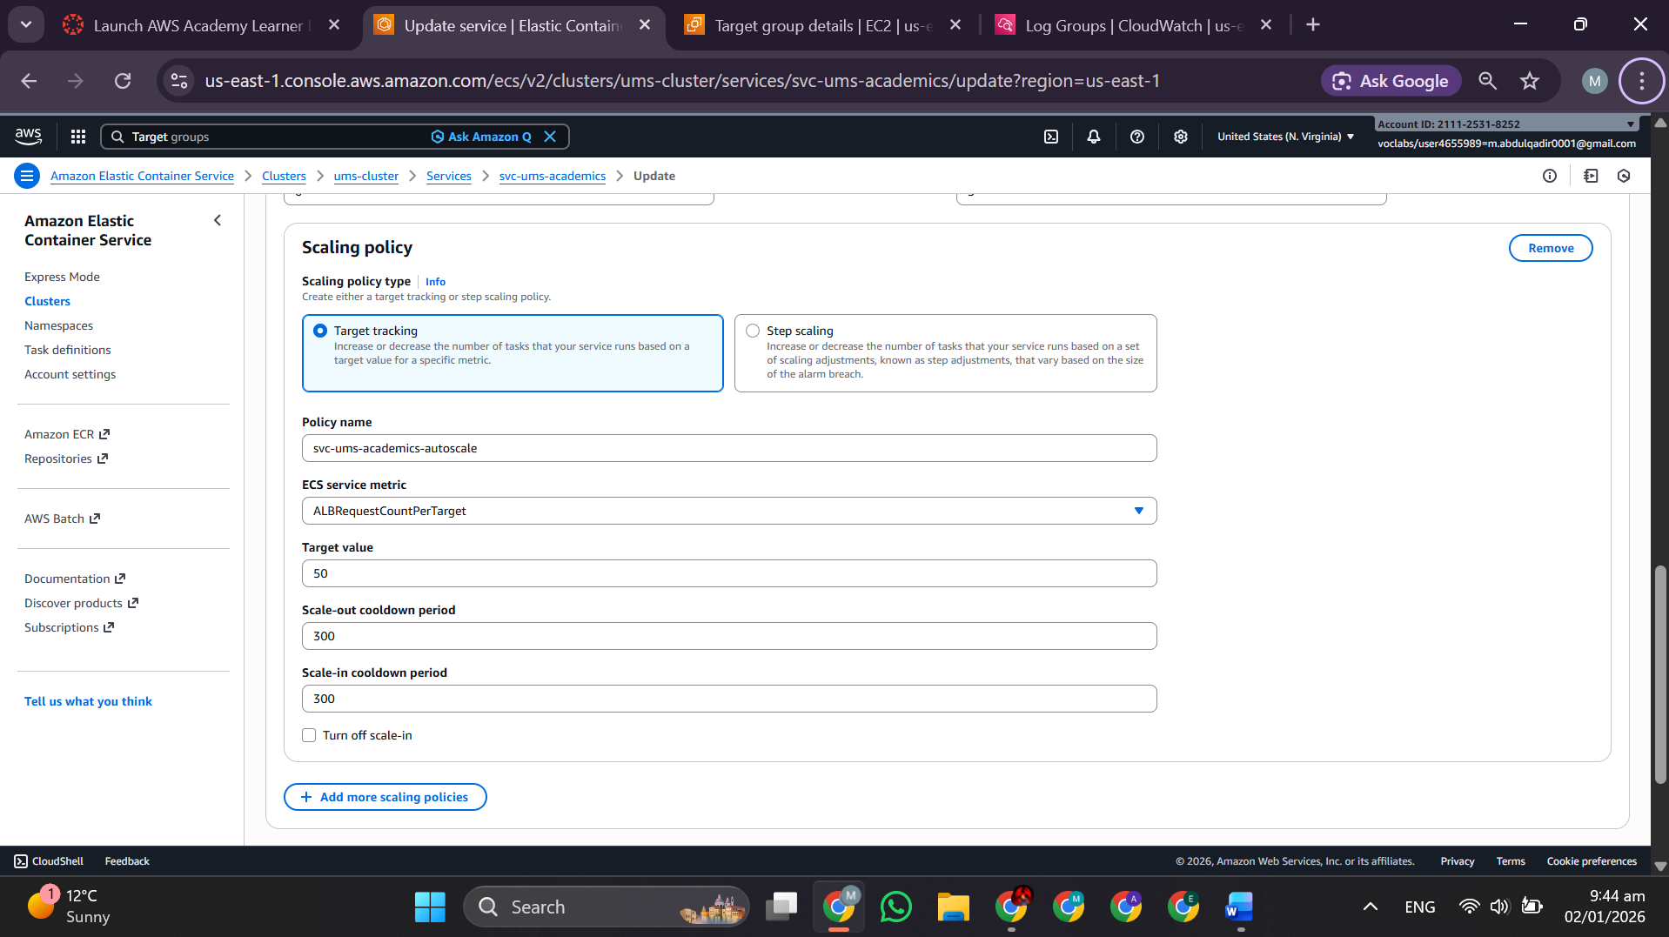

* Rules: Scale out if CPU >70% or memory >80%; scale in if <30% CPU or <50% memory
* Task count: 2–10 per service (responsive to demand)

**2.2.11 – Monitoring & Logging (CloudWatch)**

* *CloudWatch on ECS* – Log groups per service

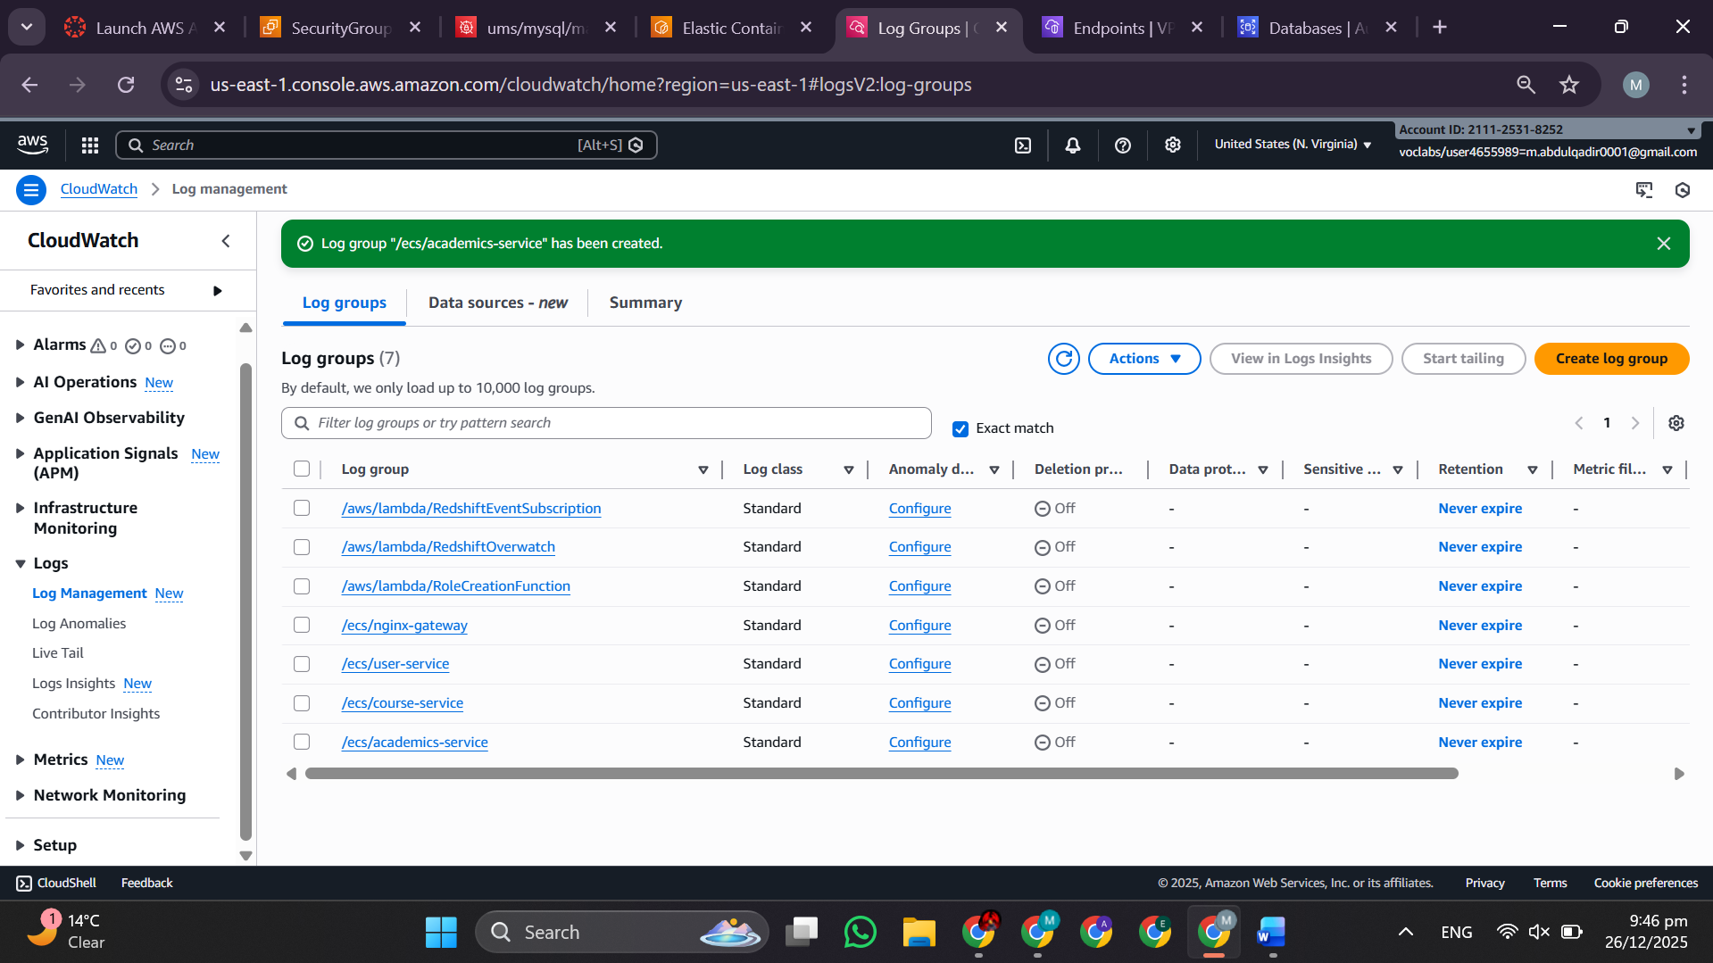

* *Logs*

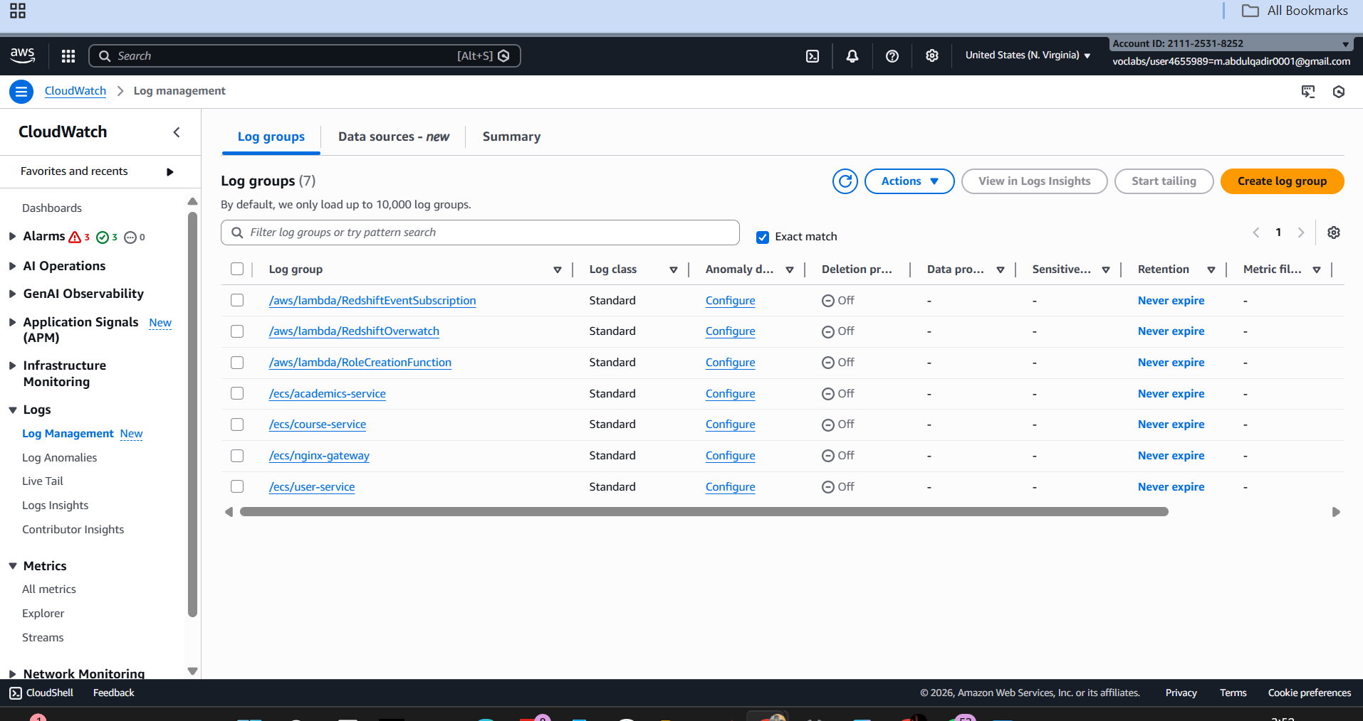

* *Alarms* – Triggered on high error rate, low task count, database issues

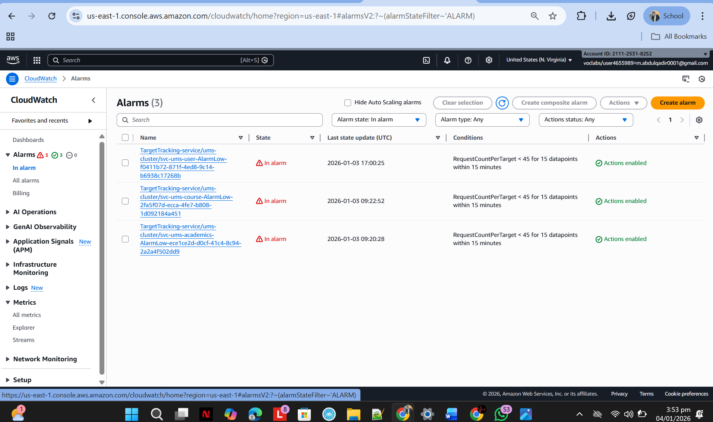

**2.2.12 – Deployment Pipeline (GitHub Actions CI/CD)**

*GitHub Actions Workflow YAML* – *Successful Deployment Log* – Build success → ECR push → ECS update → task running

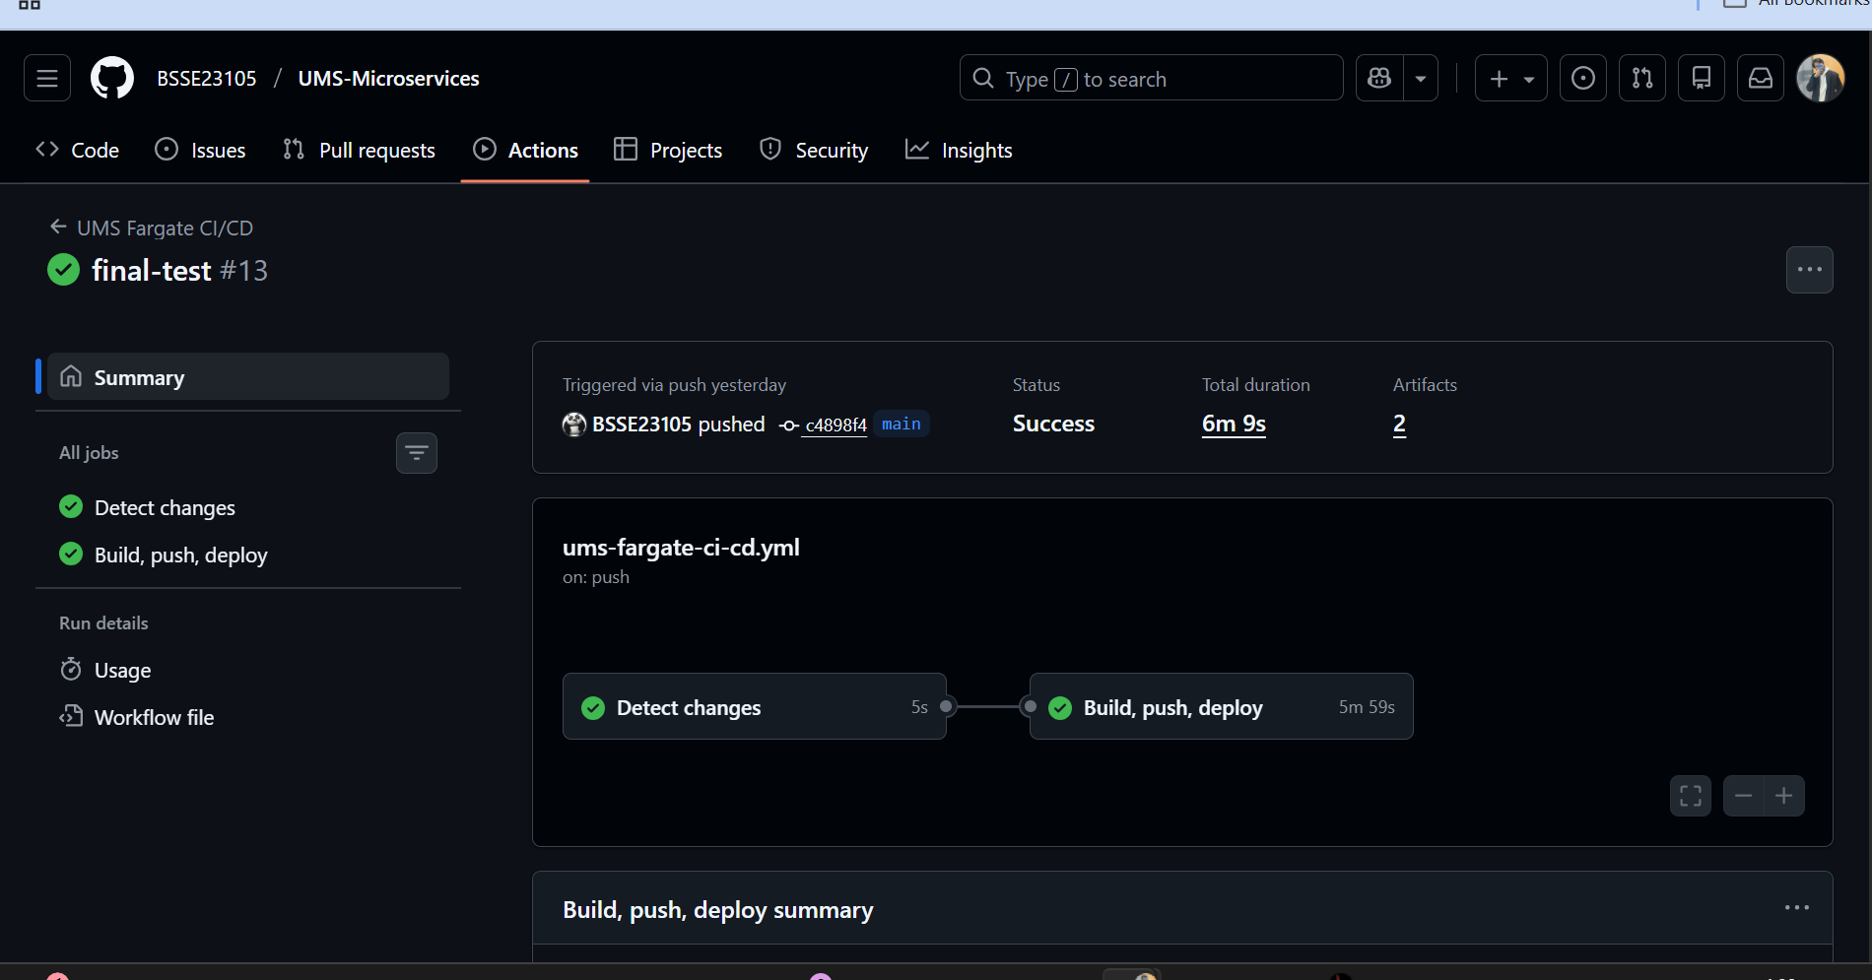

**2.2.13 – Testing & Verification (Final Output)**

* *: Postman API Test* – GET/POST to ALB endpoints:
  + http://ALB-DNS/users/register (User Management)

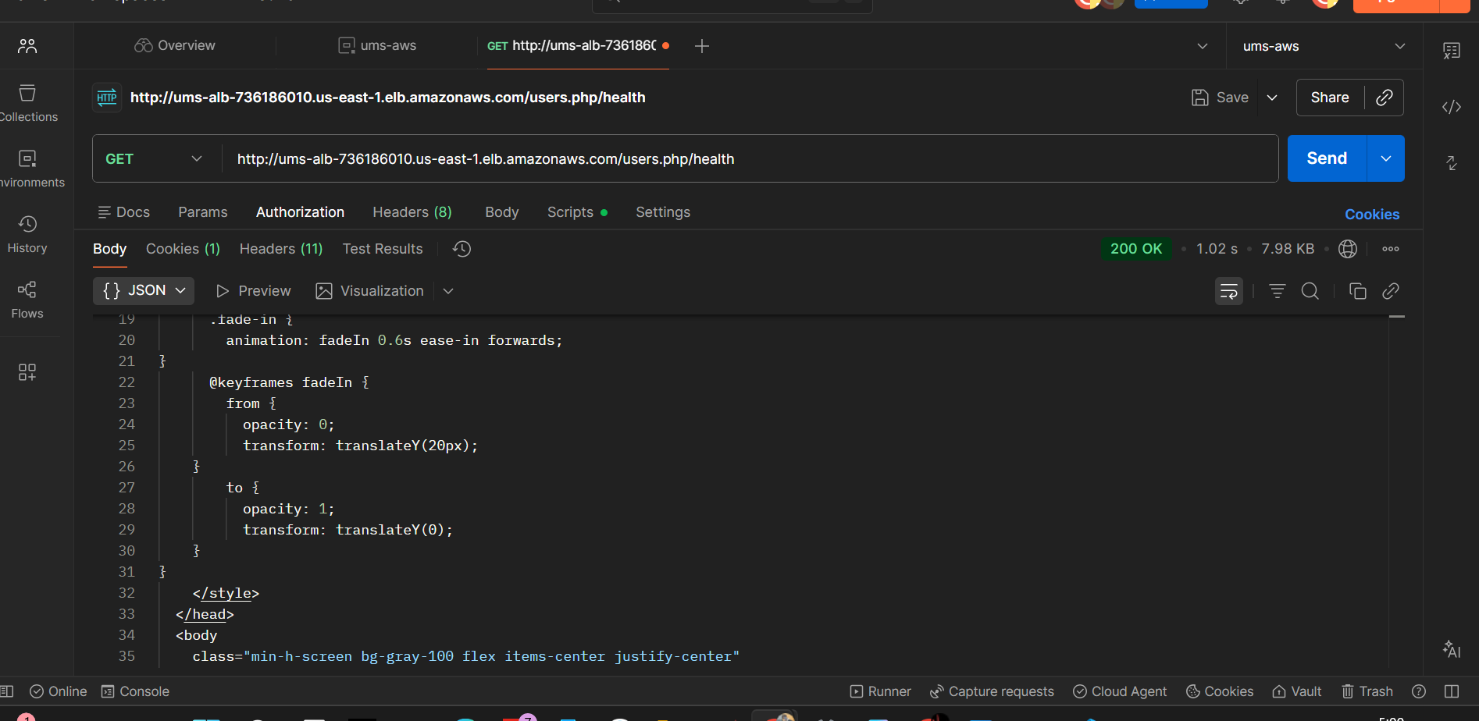

* + http://ALB-DNS/courses/list (Course Enrollment)

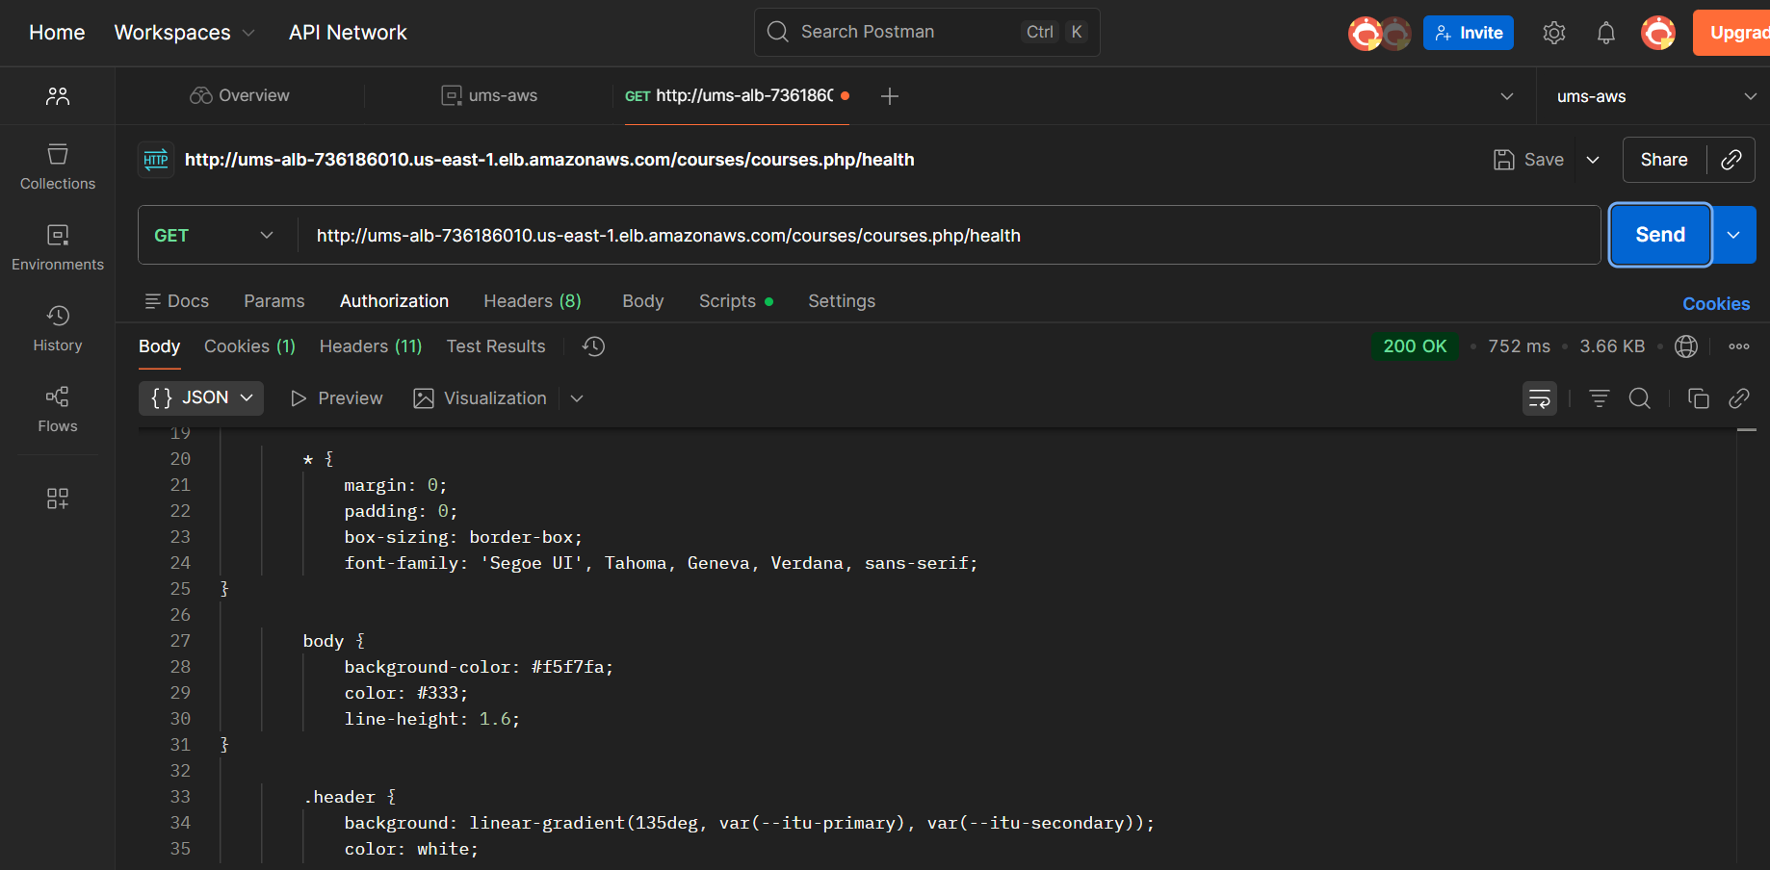

* + http://ALB-DNS/academics/messages (Messaging)

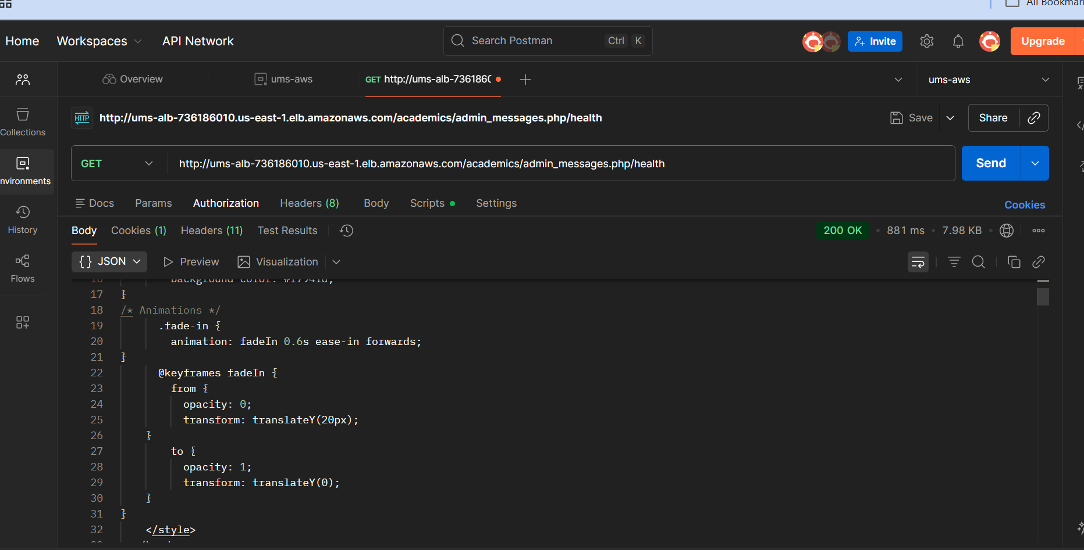

* *: Browser Portal* – Admin/Faculty/Student portals loaded via ALB DNS

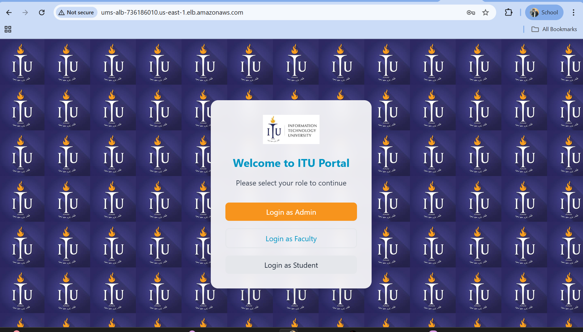

Admin portal

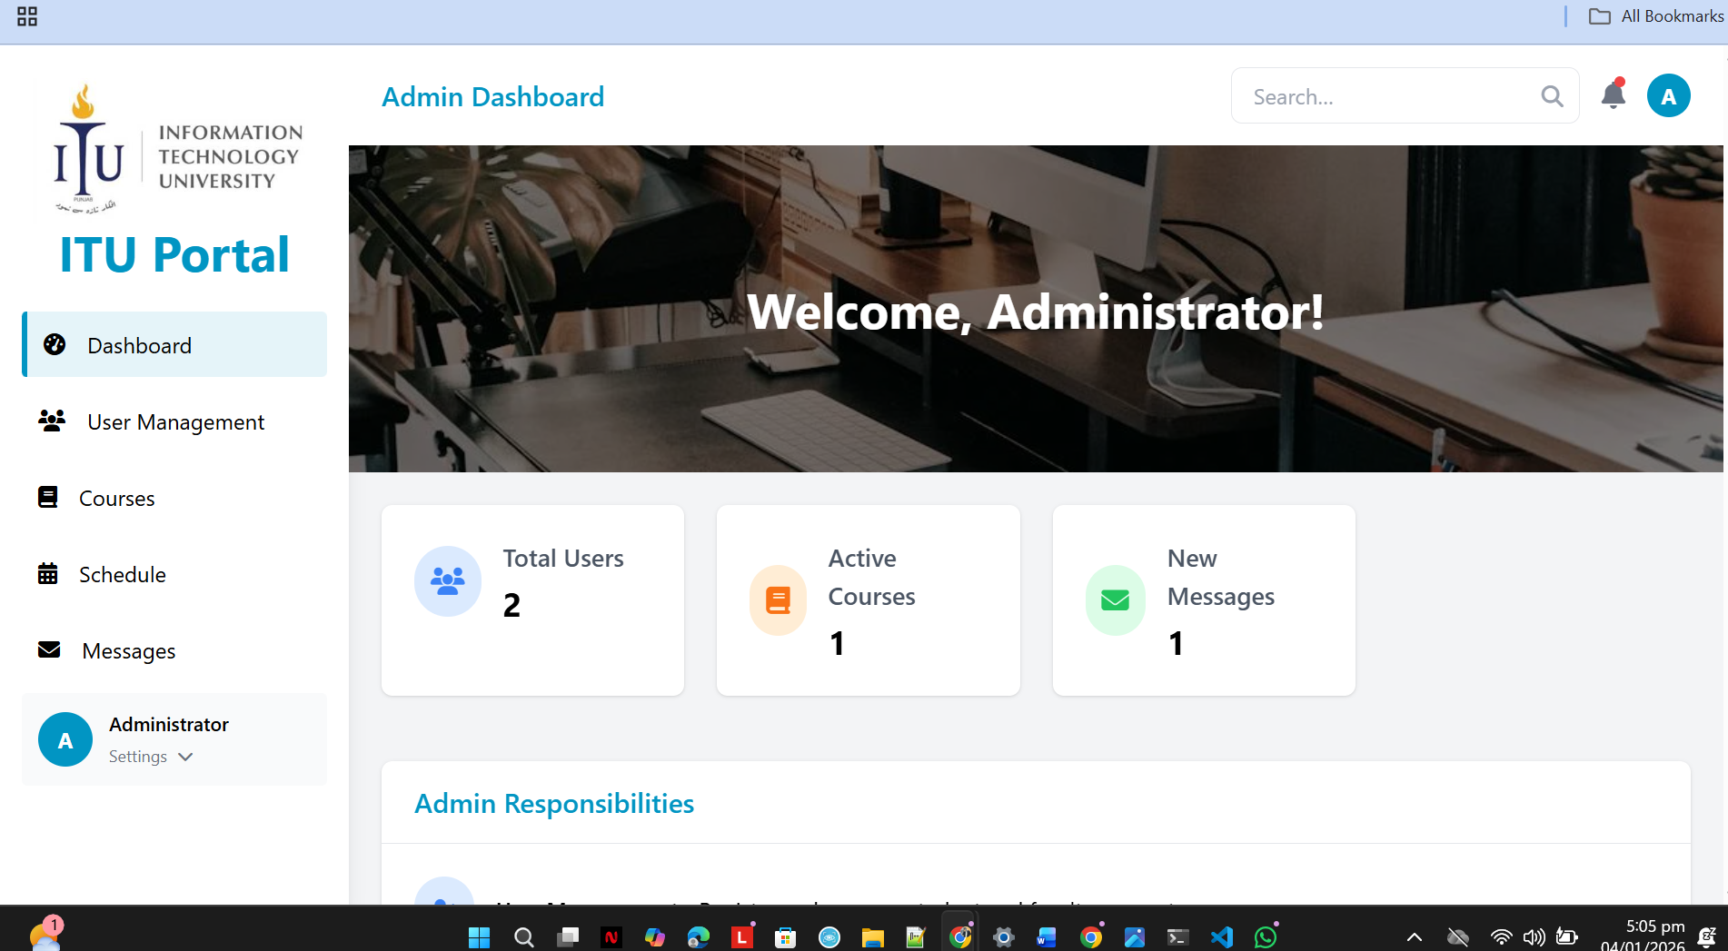

Student Portal

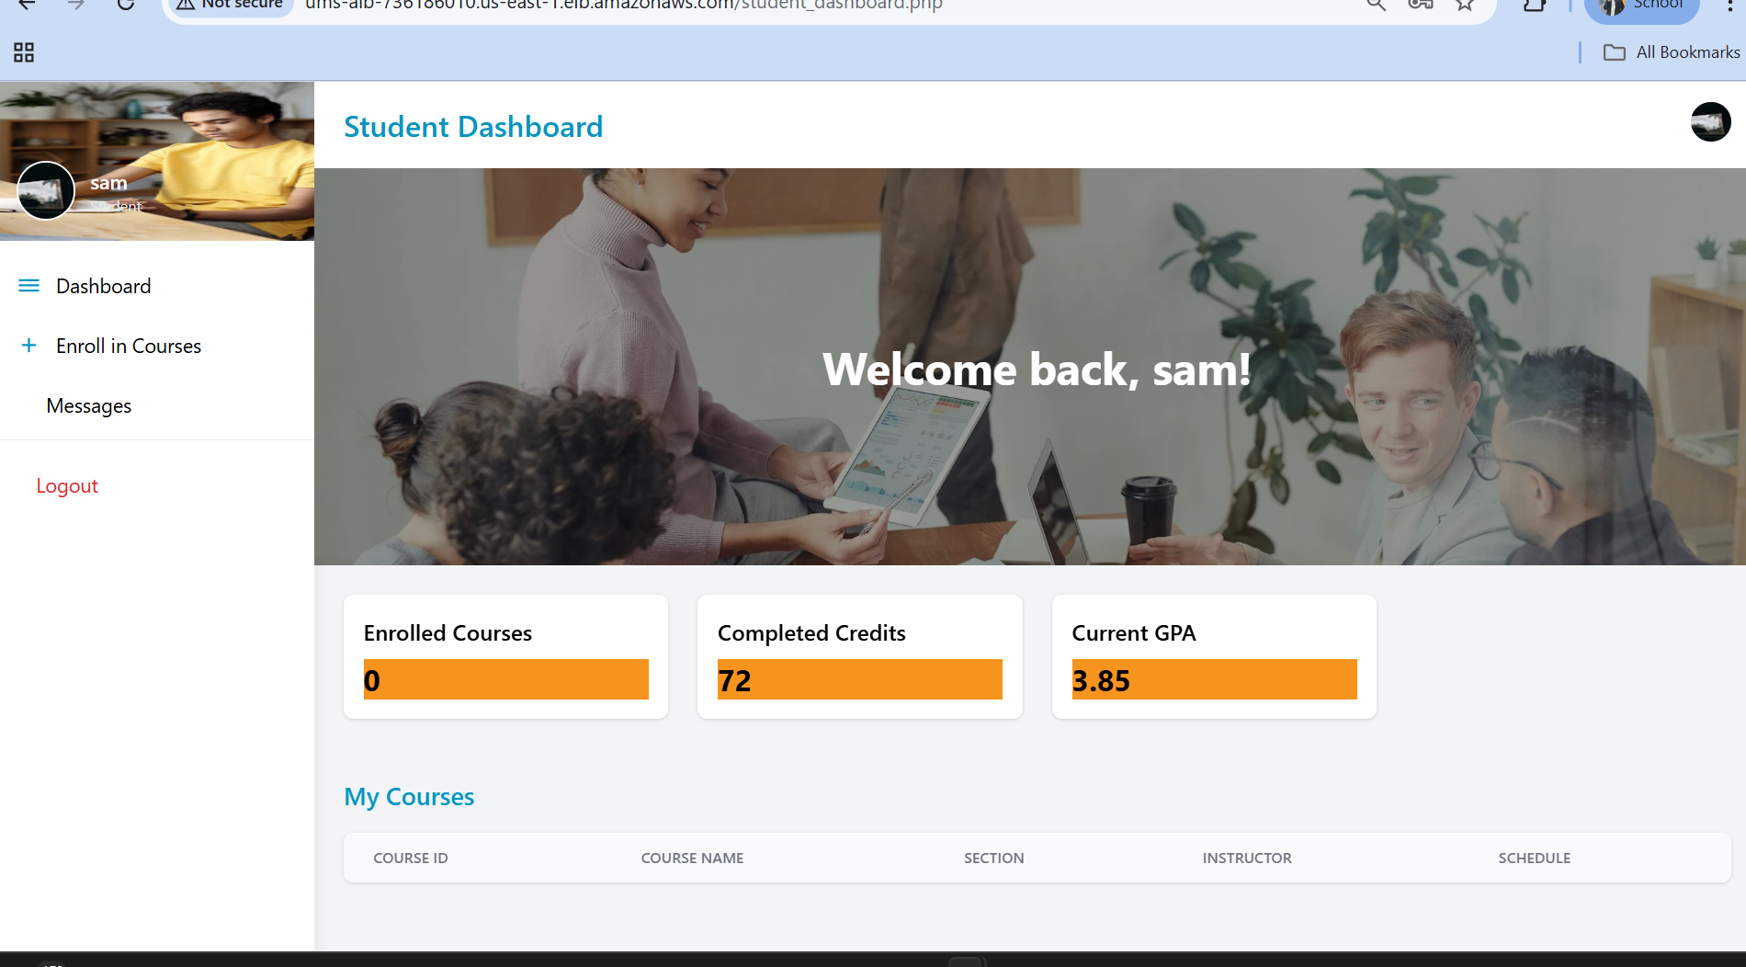

Faculty Portal

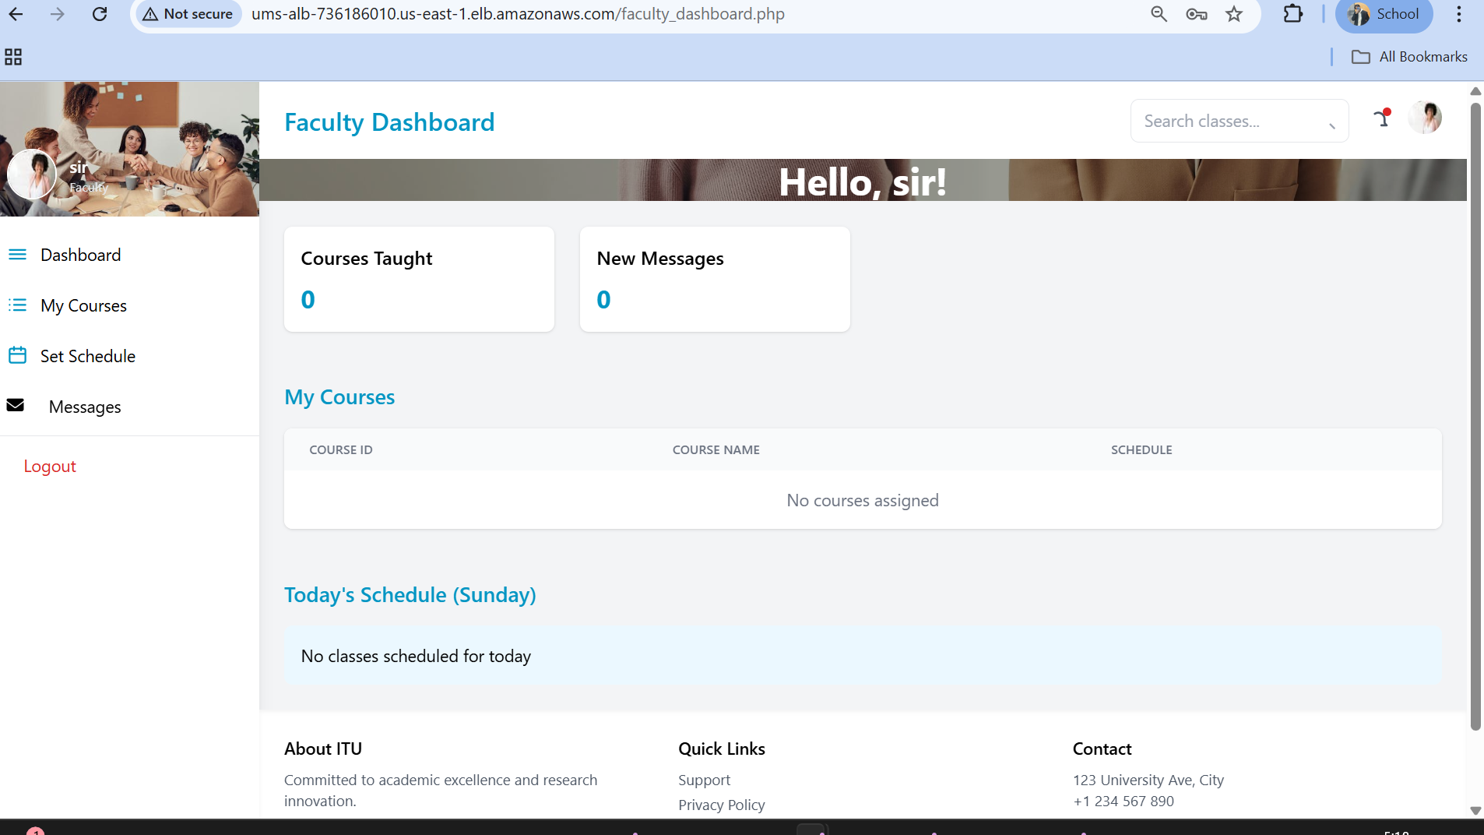

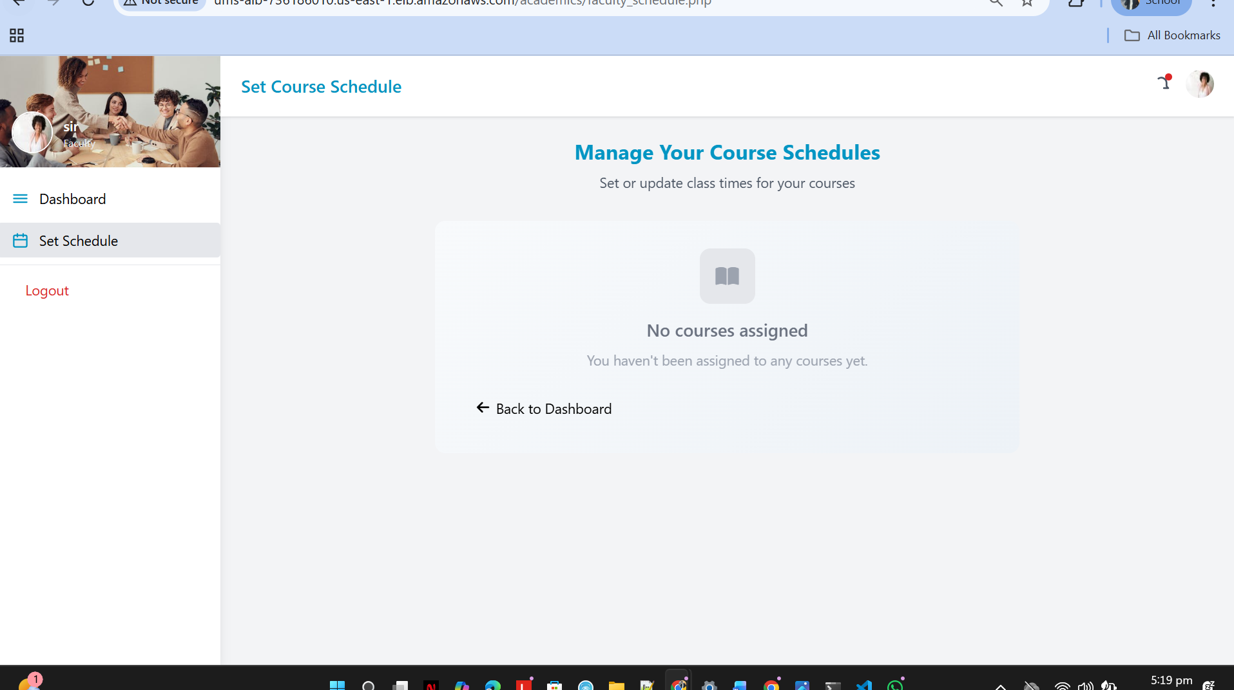

**Section 2.3: Correct Use of AWS Services (Justification Table)**

|  |  |  |  |
| --- | --- | --- | --- |
| Service | Why Chosen | Configuration (Security) | Rationale |
| ECS Fargate | Serverless container orchestration | awsvpc network mode, private subnets, 2–10 task scaling | No EC2 management; elastic scaling for 5K+ users |
| ALB | Path-based traffic routing | Public subnet, HTTP/HTTPS listeners, IP target groups | Distributes load across microservices; single entry point |
| RDS MySQL | Relational database | Multi-AZ, encrypted at rest (KMS), private subnet, SG restricted | High availability, data persistence, security |
| ElastiCache Redis | Session caching & fast lookups | Private subnet, SG restricted (ECS only), on-demand mode | Stateless ECS scaling; <10ms latency for sessions |
| ECR | Private container registry | VPC endpoint for private access, no public images | Secure image storage; VPC endpoint avoids NAT costs |
| CloudWatch | Centralized logging & metrics | Log groups per service, custom dashboard, alarms | Real-time monitoring; detect issues instantly |
| Secrets Manager | Credential management | RDS password, API keys encrypted; rotated quarterly | Never hardcoded; least-privilege IAM access |
| GitHub Actions | CI/CD automation | OIDC assume role (no long-lived keys), encrypted workflows | Rapid, secure deployments; zero downtime via canary |
| VPC Endpoints | Private AWS service access | PrivateLink for ECR, CloudWatch, Secrets Manager | Cost optimization; eliminate NAT Gateway (~$45/mo savings) |

**Section 2.4: Security & IAM (Least Privilege)**

* **VPC Network Isolation:** Public subnets (ALB, Bastion) vs. private subnets (ECS, RDS, Redis). No direct internet access from private subnets; outbound only via VPC endpoints.
* **Security Groups:** Inbound/outbound rules follow least-privilege (ALB ← internet, ECS ← ALB only, RDS ← ECS only).
* **IAM Roles:** ECS Task Execution role (ECR pull, CloudWatch logs); no user AWS access keys.
* **Data Encryption:** RDS encrypted at rest (AWS KMS); in-transit TLS; passwords hashed (bcrypt, cost=10).
* **Secrets Management:** Database credentials stored in Secrets Manager; rotated quarterly.
* **Logging & Audit:** CloudWatch Logs capture all ECS activity; CloudTrail logs IAM/resource changes (compliance).